**Forecasting Energy (2018-2040)**

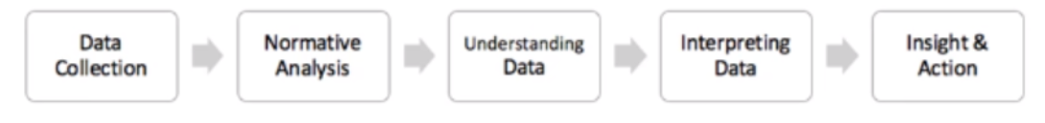

1. **DATA COLLECTION**

|  |  |
| --- | --- |
| Data Source | **Details** |
| <http://censusindia.gov.in/2011-prov-results/prov_rep_tables.html> | Population of states (2011)  (table1) |

1. **Population of states (rural vs. village):**
   1. **Assumption**: 1.3% YoY Growth
   2. With annual growth pf 1.3% Year over year, the population is calculated from 2012-2021
   3. Assumption validated by cross checking with Decadal growth rate of each state and converting into annual rate

* current value (1+Annual rate) ^10=current value(1+decadalRate)

1. **Forecast the Energy Consumption (based on Population): (2018-2020)**
   1. For the year 2014-2017 the relationship between Population as Independent variable and Energy consumption as Dependent variable is explored by using Linear Regression region wise and across regions.
   2. The following slope and Intercept have been achieved

|  |  |  |
| --- | --- | --- |
| Region | Slope | Intercept |
| East | 0.001929 | -468847 |
| North-East | 0.001198 | -48298 |
| North | 0.004503 | -1574704 |
| South | 0.006427 | -1458293 |
| West | 0.005641 | -1367641 |
| Overall | 0.0061549 | -12250 |

* 1. By using these coefficients, the energy consumption for period 2018-2020 is predicted.
  2. Using these predicted energy consumptions, now Tableau can evaluate a forecast till 2040 using exponential smoothing curve, as we have more than 5 period values.